**AWS Configuration:**

**1.Create IAM user(**[dynamoDB-cli](https://console.aws.amazon.com/iam/home" \l "/users/dynamoDB-cli)**) with Administrator Access.**

**2.Note down the secret key and access key.**

**This secret key and access key will be use in our application to connect AWS services.**

**3.Create Dynamo DB table Payment(partion Id:OrderId) and Order(partion Id:paymentId)**

**4.Create SQS queue(payment-updates,restraunt-updates,order-updates)**

**5.paste the ARN no. for IAM user in below “Only the specified AWS accounts,IAM and roles” in both options.**

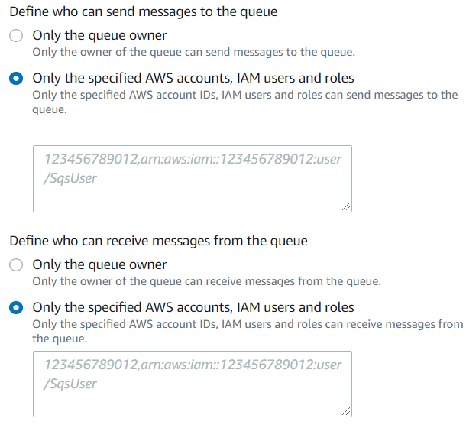

**Executing the Application:**

**1.Run the order-service application.**

**2.Open the command prompt and run below commands**

* **To check the all the services.**

grpcurl --plaintext localhost:9090 list

com.dutta.shared.OrderService

grpc.health.v1.Health

grpc.reflection.v1alpha.ServerReflection

* To get endpoints.

grpcurl --plaintext localhost:9090 list com.dutta.shared.OrderService

com.dutta.shared.OrderService.createOrder

com.dutta.shared.OrderService.getOrder

* To Execute create Order.

grpcurl --plaintext -d "{\"customerId\": 4,\"sellerId\": 104,\"product\": {\"productId\": 204,\"productName\": \"pizza\"},\"paymentMethod\": \"WALLET\",\"deliverLocation\": \"chennai\"}" localhost:9090 com.dutta.shared.OrderService/createOrder